**How to Start your ProfitPilot**

1. First buy ProfitPilot here: digitaltradingsoftware.com/profitpilot
2. Create a new folder on your disk and download the files.
3. Run the file “Start-Pilot”. You can click on it (or run it in a ‘command’ window).  
   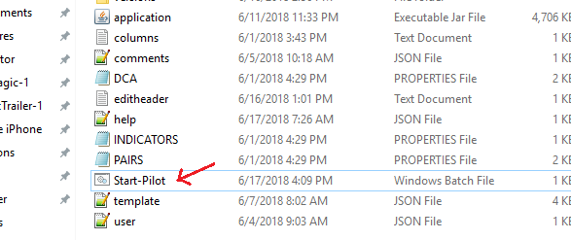
4. Copy the Manager-ID shown. Register the Manager-ID on the website, follow the instructions.   
   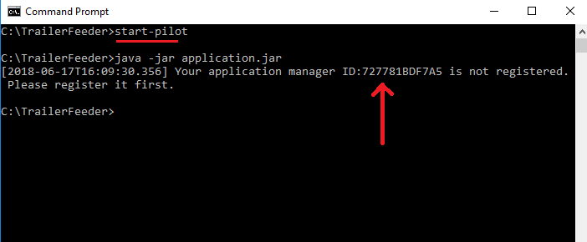
5. You will be activated and receive an email with your Product-ID. This is your activation key.
6. Paste your Product-ID in the “user.json” file.

**Setting up your “User.json” file:**

* Open the “User.json” file using notepad++. Paste your Product-ID.
* Enter the location of your PT Feeder path, where you installed it.
* Enter your ProfitTrailer key. This is needed to upload to ProfitTrailer.
* If you don’t want to enter your ProfitTrailer key you can turn off upload by setting “uploadSettings”: “false”

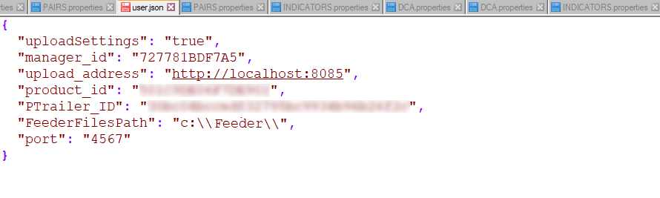

Run ProfitPilot!

You are now ready to run it. Click on the file “Start-Pilot.bat”